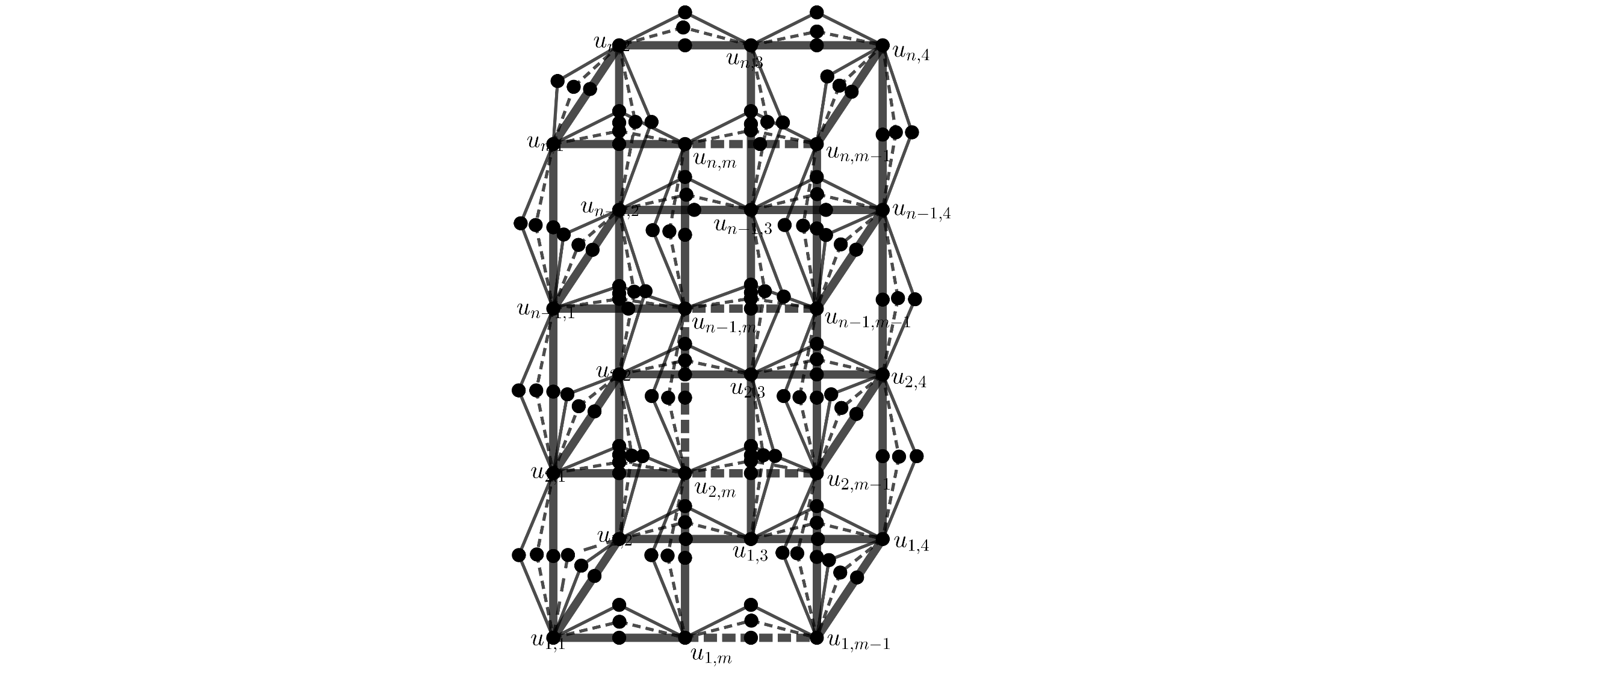
BrntukUmum Graf $SSD_{k}\left(D_{m,n}\right)$
$SSD_{k}(D_{m,n})$ dengan $m≥3$ dan $n≥2$

Syarat pelabelan radio: $\left|f\left(u\right)-f(v)\right|=diam k+1-d\left(u,v\right)$

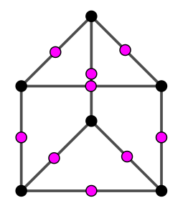
$$SSD_{1}\left(D_{3,2}\right)$$

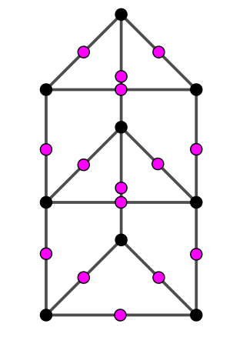
$$SSD_{1}\left(D_{3,3}\right)$$
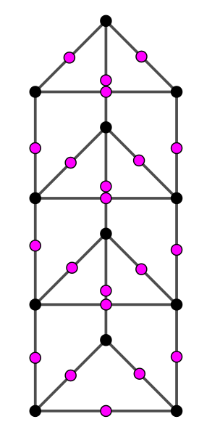
$$SSD_{1}\left(D_{3,4}\right)$$

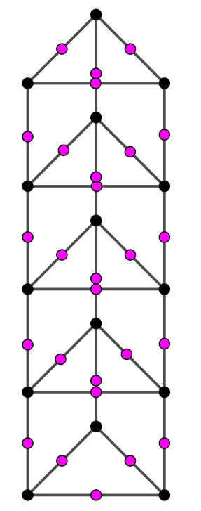
$$SSD_{1}(D_{3,5})$$
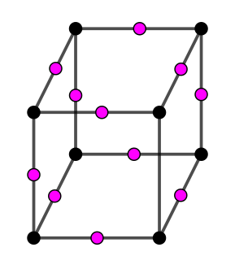
$$SSD_{1}\left(D_{4,2}\right)$$

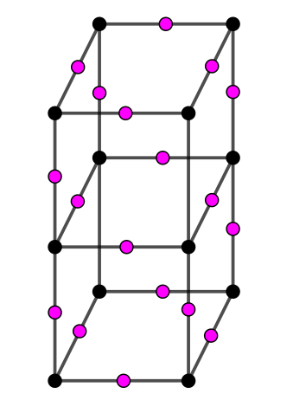
$$SSD_{1}(D_{4,3})$$

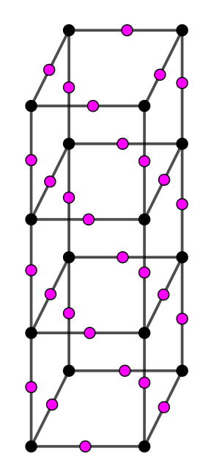
$$SSD_{1}(D_{4,4})$$

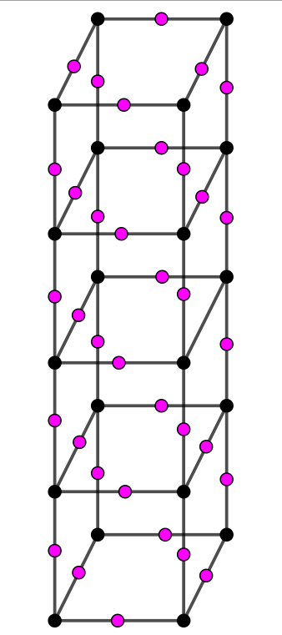
$$SSD_{1}(D_{4,5})$$
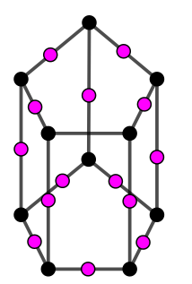
$$SSD_{1}\left(D_{5,2}\right)$$

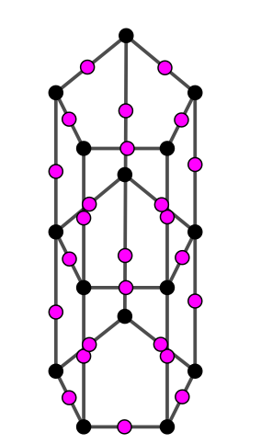
$$SSD_{1}(D_{5,3})$$
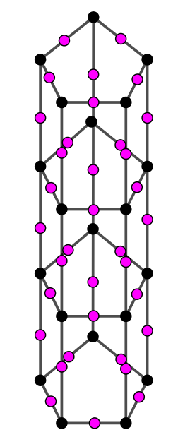
$$SSD_{1}\left(D_{5,4}\right)$$
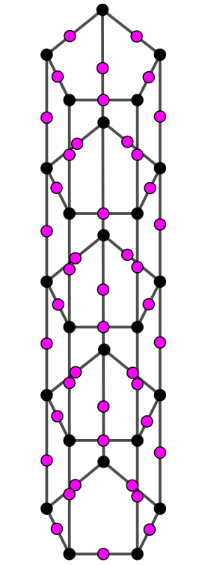
$SSD_{1}(D_{5,5})$
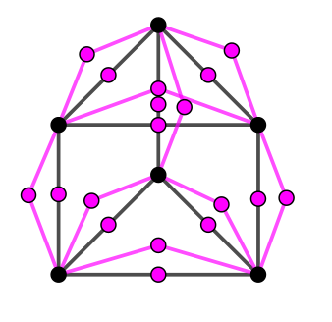
$$SSD_{2}(D_{3,2})$$

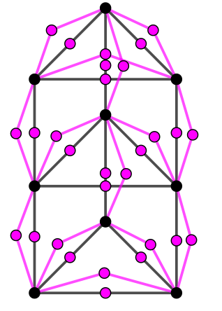
$$SSD_{2}\left(D_{3,3}\right)$$

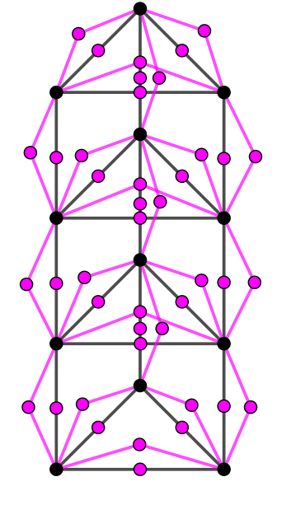
$$SSD_{2}(D_{3,4})$$
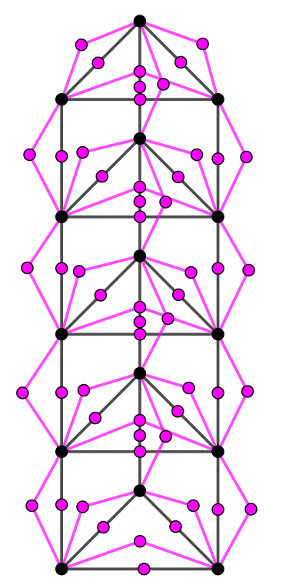
$$SSD_{2}(D_{3,5})$$

